Protocol: Voltage threshold calculations and comparison to RMP for cell health cutoffs

Concatenating Files
- Open the metadata (or RMP file) to acquire the animal ID, sample #, .abf and other info for all the action potentials you want to analyze
- Depending on number of files you want to analyze it is good to break the concatenation up into chunks (analysis template has 25 cell chunk)
- Open an action potential file (from the “Fine” protocol)
- Right click Select sweep… where the first AP was fired (if another sweep has an AP, confirm similarity in dynamics and choose the best one – use that sweep for all future AP parameters for this cell)
- File, Save As with just the sweep with the AP visible – save with sample #, abf in name
- Save in folder where you will eventually concatenate all AP sweeps together into one file
- Once your chunk of cells have been saved into individual AP files, open all of them in clampfit
- Go to Analyze Concatenate Files
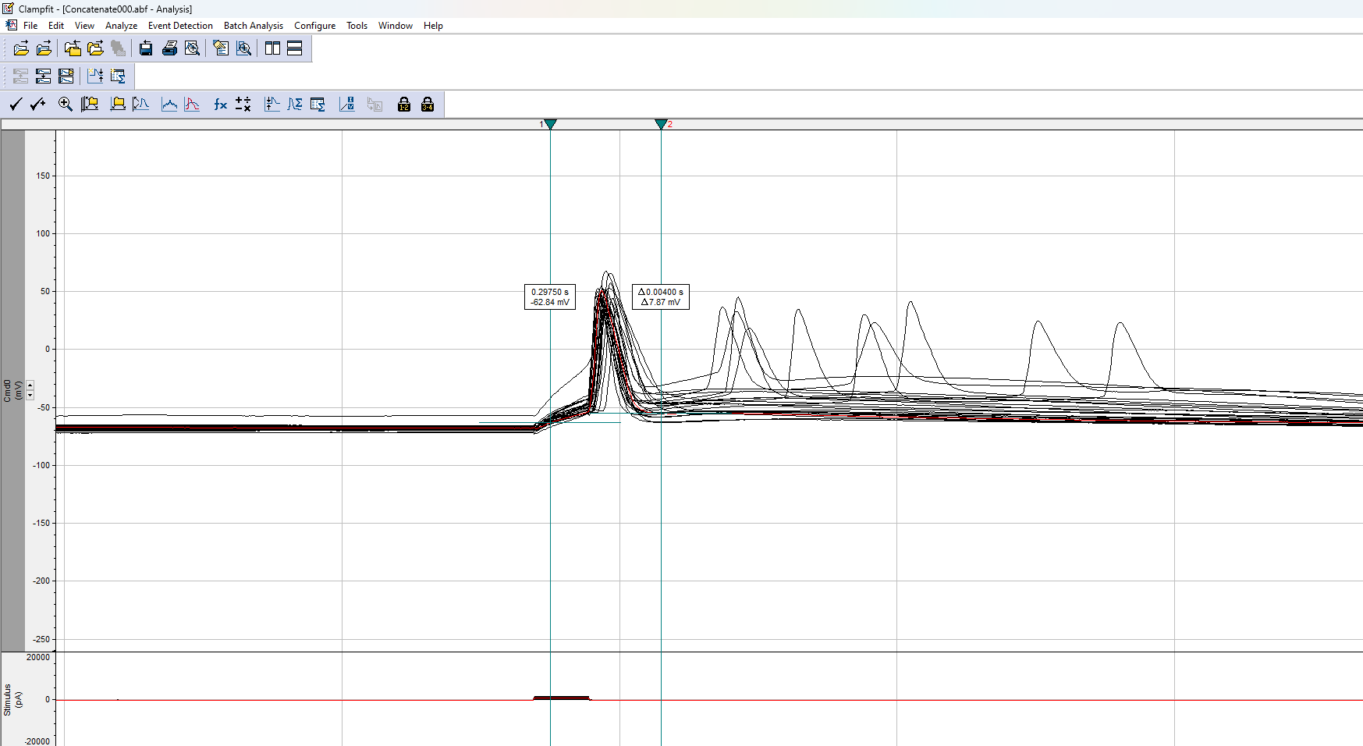
- This concatenated file of all your APs will save as “Concatenate000” in the same folder
- Confirm that the number of sweeps matches the number of cells you analyzed in your chunk. If it doesn’t match up, you probably included a subthreshold sweep or a duplicate
Collecting the Trace Data for dv/dt and Threshold Calculation
- Set cursors 1 and 2 at the following positions:
  - 0.2975
  - 0.3015
- Edit Transfer Traces…
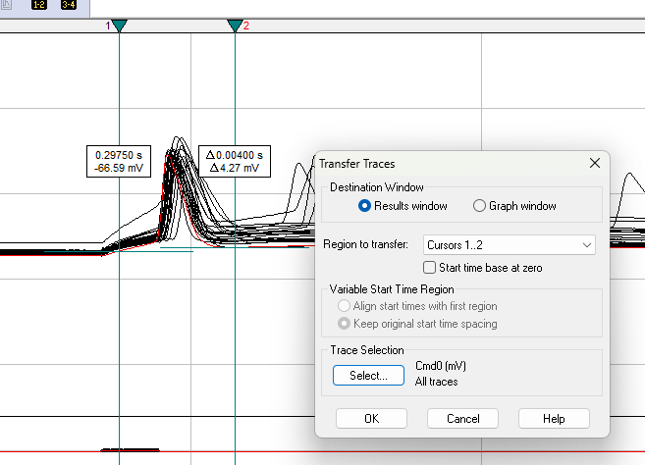
- Select results window, Cursors 1..2, and Cmd0, All traces Ok
- All the datapoints from each trace will be in the Results1 window
- Copy and past these values, including the time column, into the Voltage Threshold and RMP cutoff Analysis Template at the appropriate location (again, up to 25 cells)
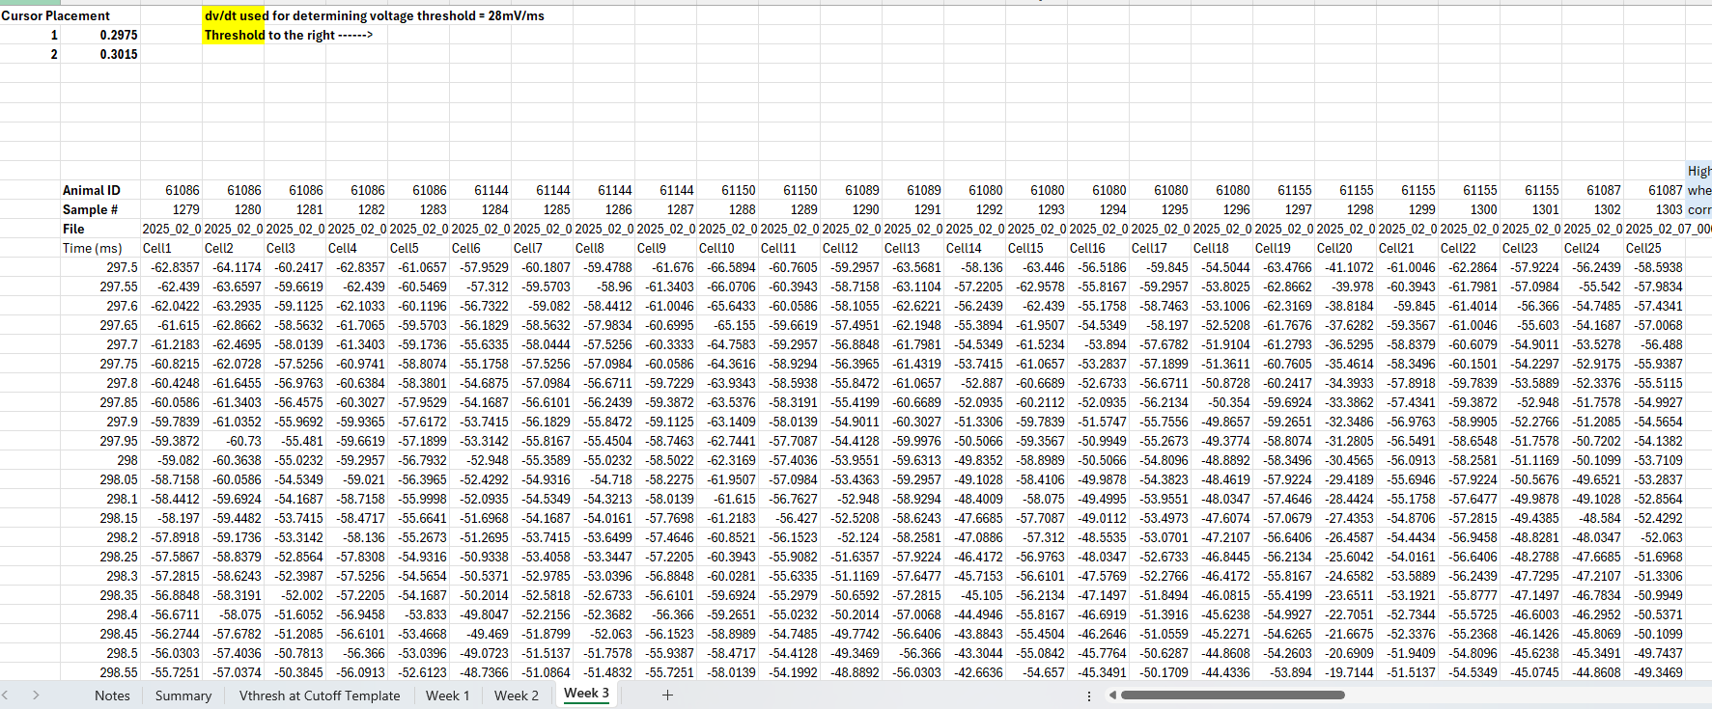

- Copy and paste the metadata into the correct column above each cell
- The dv/dt and threshold analysis cells to the right should populate:
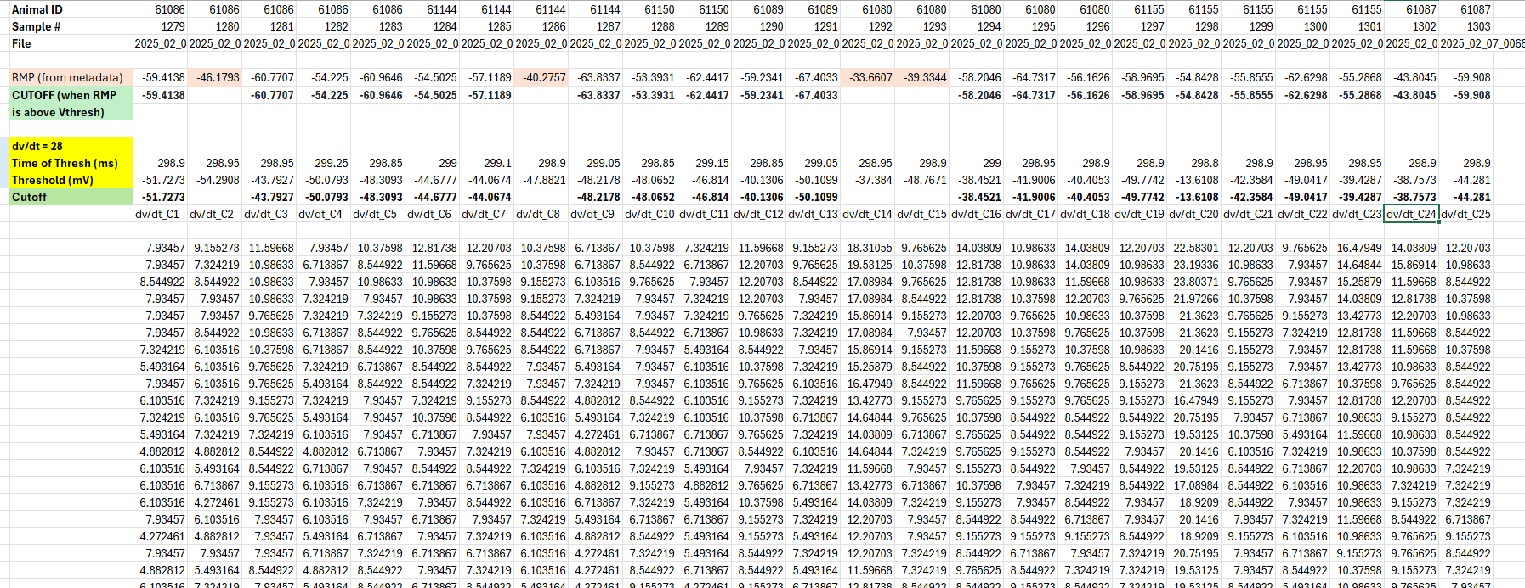
- Copy and paste from the metadata the RMP for each cell into the RMP row
- Read the “Notes” tab for full explanation of Threshold calculation based on a rise of 28 dv/dt and the cutoff rule when comparing to the RMP

Confirm Threshold Manually
- Go back to concatenated trace and confirm by eye that each location of threshold that was calculated (in yellow row) is an acceptable place for threshold (avoid pipette compensation artifacts in trace)
  - Do this by entering in cursor 1 position the “Time of Thresh” row value
- If you deem the location unacceptable for threshold, move it and record the mV value you chose – label in blue
- If you deem AP waveform looks “weird” and “not real”, exclude due to user judgement and label in red (make sure to delete vthresh values as if it were excluded by the formulas
- Compile all Vthresh values, both raw (in yellow) and bolded “cutoff” values (in green) row from all the “chunks” (weeks) into summary tab
- Average the values (raw and healthy)

